|  |
| --- |
| Lamar-Milledge Elementary  2025-2026 Kindergarten Supply List  Ms. Davis  Ms. Garnett  Mrs. Nelson |



* 6 spiral notebooks
* 1-3 ring binder (1 inch or 1 ½ inch- hard cover with inside pouches, prongs, and clear plastic insert on front cover)

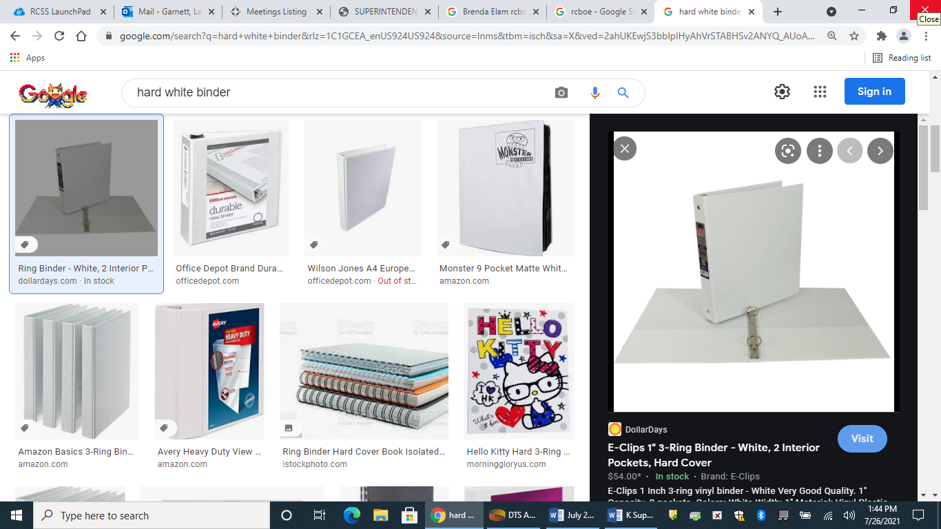

* 3 packs of jumbo kindergarten pencils
* Pink erasers
* Glue sticks
* Crayons
* 3 packs of dry erase markers
* Index cards
* Paper towels
* Kleenex
* Hand Soap
* 2 boxes Ziploc bags (Gallon and/or Sandwich size)
* Headphones with microphone (no ear buds)

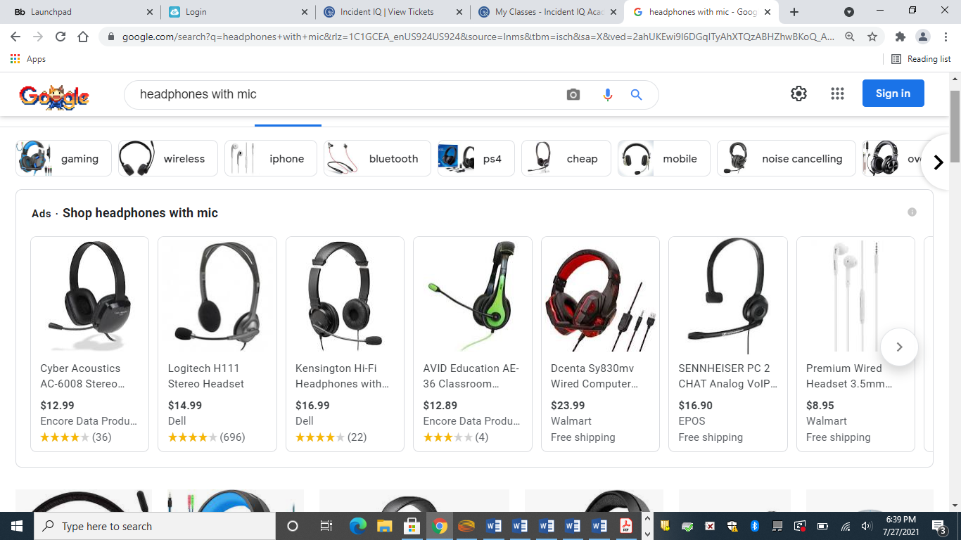

* Scissors